
西安瑞禧生物科技有限公司
Xi'an city ,Shaanxi Province,China
Web:http://www.xarxbio.com
Tel: 0086 29 86354885
E-mail:sales@xarxbio.com

Certificate of Analysis

General properties:
Name： PCL12000-PEG2000-MAL(14KDa)
Molecular Weight： PEG MW:2000 Dalton PCL MW:12000
Cat.#： R-1105-212K
Lot.#： RP0160885
Date of Analysis： 2016.08.08
Recommended Retest date： 2017.08.08
Stability： 12 months
Storage： -20°C in the dark

Structure

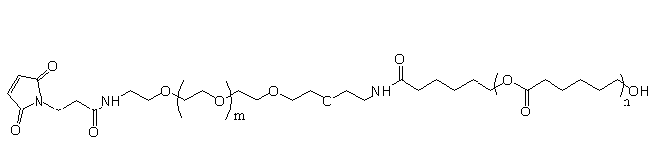

Items | Specification | Results
Appearance | White/ off-white solid | White solid
¹H NMR | Identical to the structure | Identical to the structure
Foreign Material | None | None
Substitution | ＞90% | ＞90%
Report Date: 2016.08.08

This product is for research use only, Not for human or animal use

